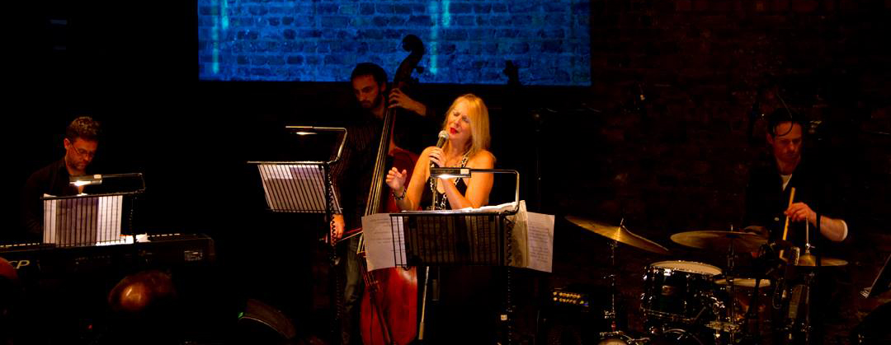
Melanie O’Reilly

While Melanie O’Reilly was born on the southside of Dublin, she found a spiritual home in American jazz at an early age.

Hailing from a family of artists, Melanie sang and acted on stage as a child. At the age of 11, jazz had already engulfed her thanks to Ella Fitzgerald’s extraordinary voice and the music of Billie Holiday, Sarah Vaughan, Miles Davis and Dizzy Gillespie.

“I remember the moment I first heard Ella Fitzgerald sing ‘It don’t mean a thing if it ain’t got that swing’ with the Duke Ellington Orchestra. I’ve been swinging and scatting and in love with jazz ever since.”

Alongside her immersion in this great American art form, Melanie discovered the beauty of Irish music at the Foxrock Folk Club.

Celtic Jazz

After studying dramatic performance at the Brendan Smith Theatre Academy, Melanie started her professional career as a singer who blended American jazz with Irish traditional music to create Celtic Jazz – her trademark.

“I was lucky enough to hear live performances of Irish traditional musicians at the famous Foxrock Folk Club as a young teenager. Their performances were followed by Dublin jazz musicians such as the Louis Stewart Trio. The night both The Chieftains and Louis Stewart Trio jammed together blew my mind.”

“I knew I was witnessing something special. An incredible fusion of two great traditions: Irish Trad music blending with the American art form. Old yet new.”
Albums and Tours

Melanie has released a number of jazz albums strongly influenced by her Irish heritage including Oileán Draíochta, Dust and Blood and Ceol Ceantair.

Her album House of the Dolphins was well received by critics and resulted in nominations for Best Contemporary Album and Best Female Artist by Irish Music Magazine.

Over the years, she has worked with a host of stellar musicians.

The late, great guitarist Larry Coryell featured on Oileán Draíochta while Melanie has also shared the stage with Oliver Jones, Darius Brubeck, George Brooks, Simon Rowe, Frank Martin, and Louis Stewart.

She has toured extensively across the United States and Europe. Previous stops include the Lincoln Center in New York, London’s Barbican Centre, Edinburgh Festival Fringe, Andernos Jazz Festival, Cork International Jazz Festival and Dublin’s National Concert Hall.

Recent Work

In 2011, Melanie debuted her show Jazz on a Summer’s Day: a Tribute to Anita O’Day. O’Day was a pioneering singer renowned for her vocal virtuosity and colourful private life. It received four-star reviews at the Edinburgh Festival Fringe during its run there, and continues to garner praise wherever she performs it.

2013 saw Melanie’s Celtic Jazz Ensemble perform at UCLA’s European jazz showcase EUropean Jazz @ UCLA. She was accompanied there by George Brooks (saxophone), Frank Martin (piano), Fred Randolph (bass) and Surya Prakasha (drums & percussion).

Away from the stage, she has also found success in radio.

Melanie’s series Jazz on the Bay, in which she interviewed icons from the world of jazz, was broadcast on RTÉ Radio 1 for six seasons.

The programme featured conversations with Dave Brubeck, Chick Corea, Clint Eastwood, Nancy Wilson and a host of other stars. Well received during its run, Jazz on the Bay won a PPI/Irish National Radio Award for Music Specialist Programme of the Year.

Melanie continues to perform and also teaches vocal performance. After 14 years in Berkeley, California, she recently returned to Ireland and now divides her time between Europe and California.

Cover image by Jim Berkeley

